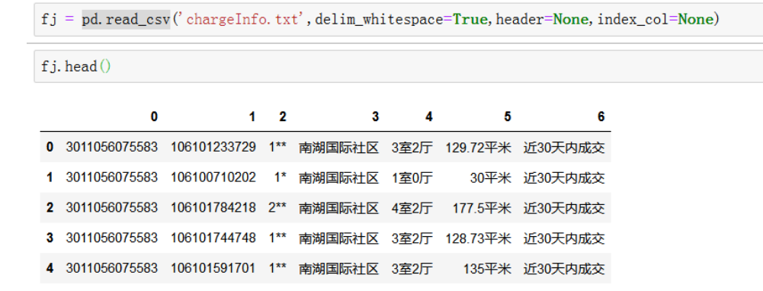

pandas.read_csv
Read a comma-separated values (csv) file into DataFrame.
pandas.read_csv(filepath_or_buffer, sep=', ', delimiter=None, header='infer', names=None, index_col=None, usecols=None, squeeze=False, prefix=None, mangle_dupe_cols=True, dtype=None, engine=None, converters=None, true_values=None, false_values=None, skipinitialspace=False, skiprows=None, skipfooter=0, nrows=None, na_values=None, keep_default_na=True, na_filter=True, verbose=False, skip_blank_lines=True, parse_dates=False, infer_datetime_format=False, keep_date_col=False, date_parser=None, dayfirst=False, iterator=False, chunksize=None, compression='infer', thousands=None, decimal=b'.', lineterminator=None, quotechar='"', quoting=0, doublequote=True, escapechar=None, comment=None, encoding=None, dialect=None, tupleize_cols=None, error_bad_lines=True, warn_bad_lines=True, delim_whitespace=False, low_memory=True, memory_map=False, float_precision=None)[source]
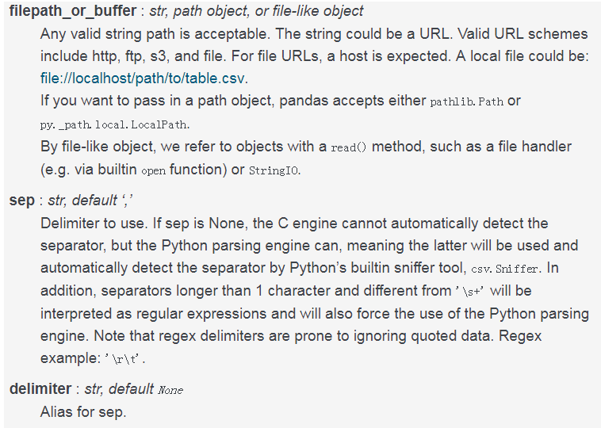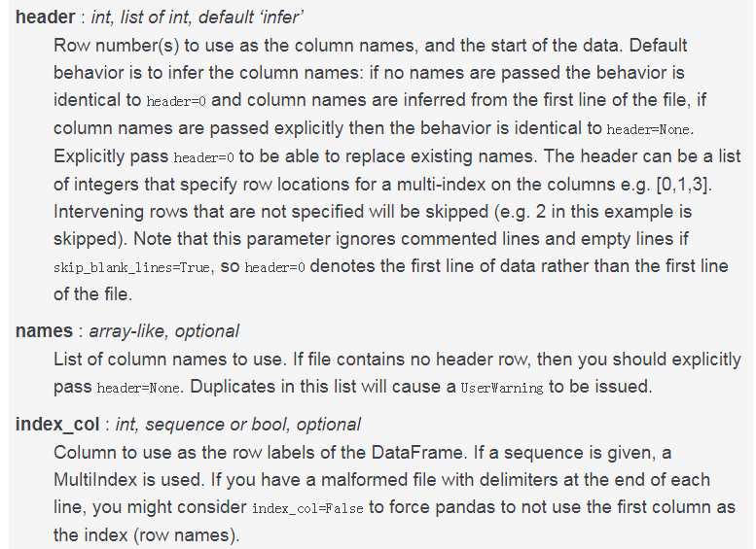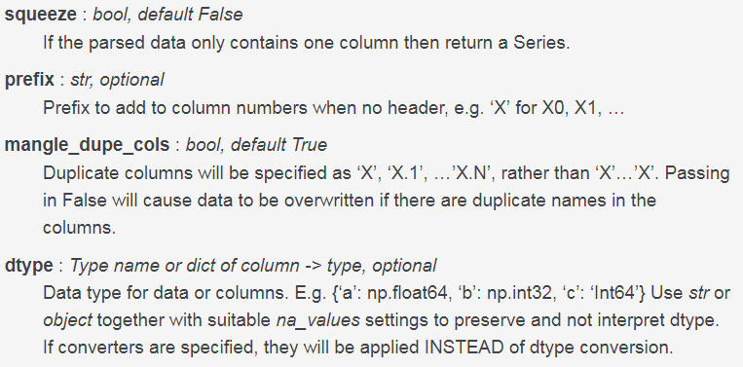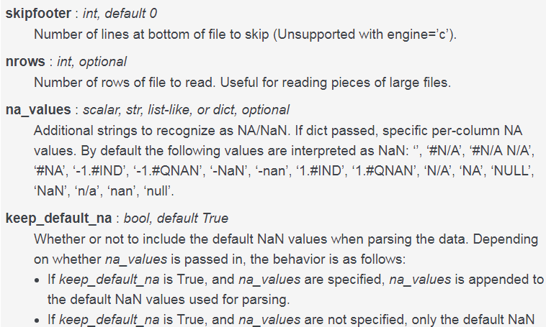


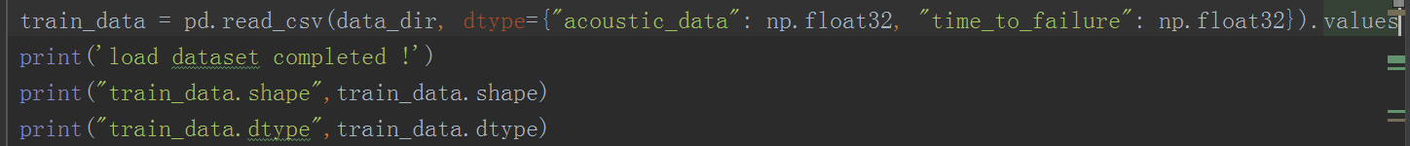
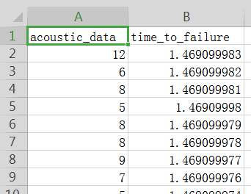
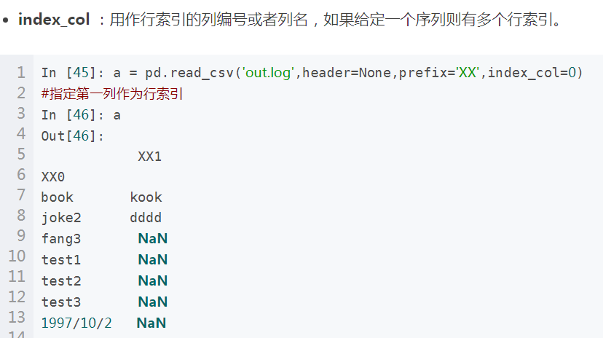
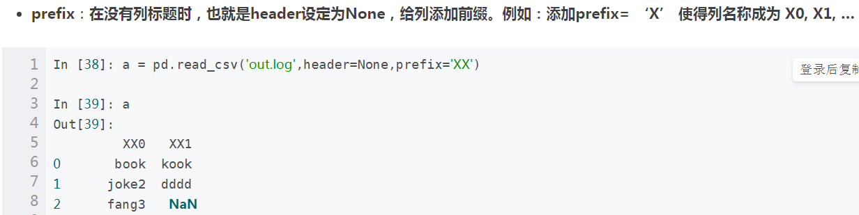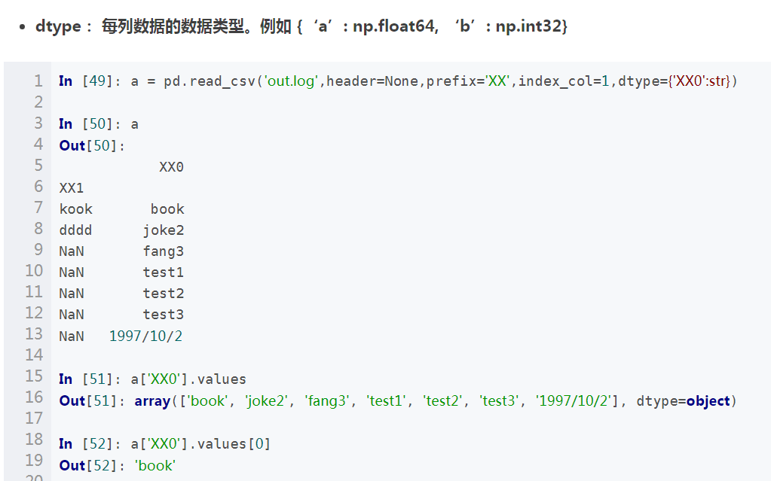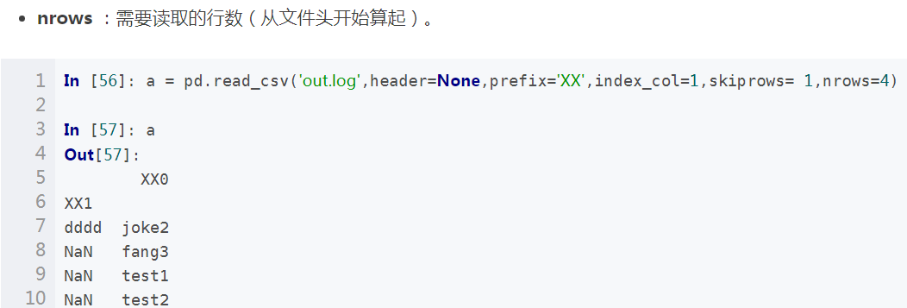
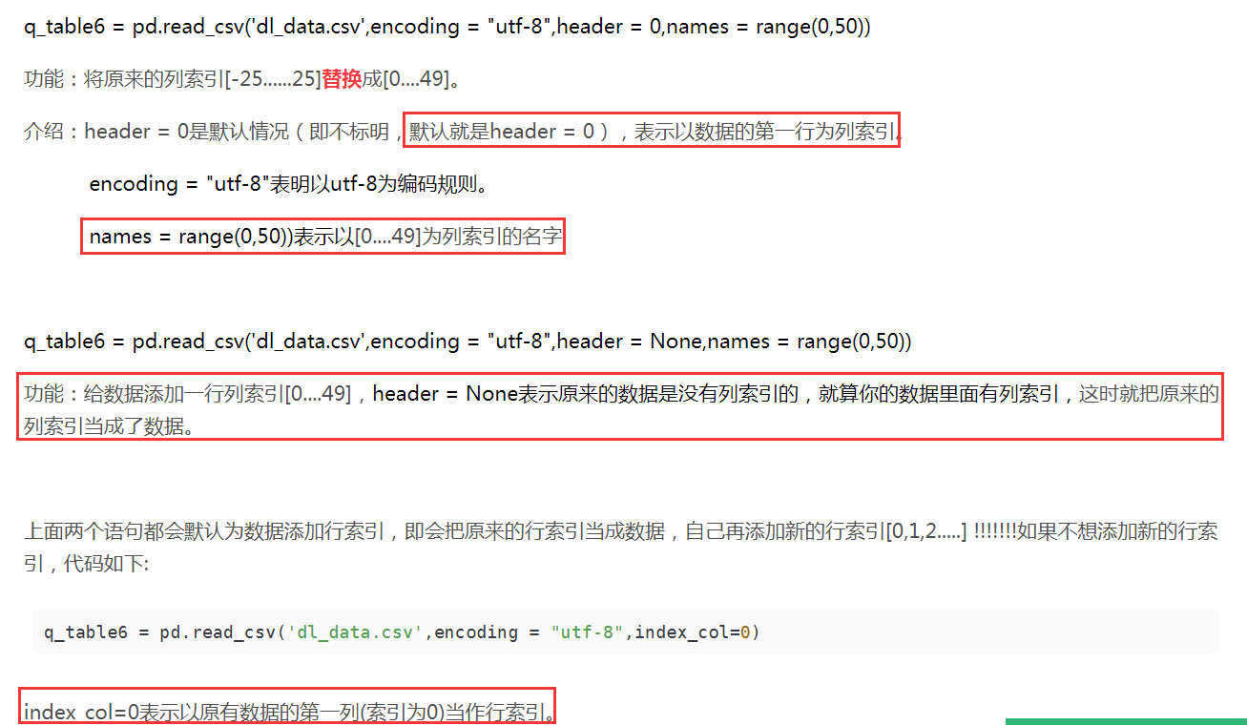

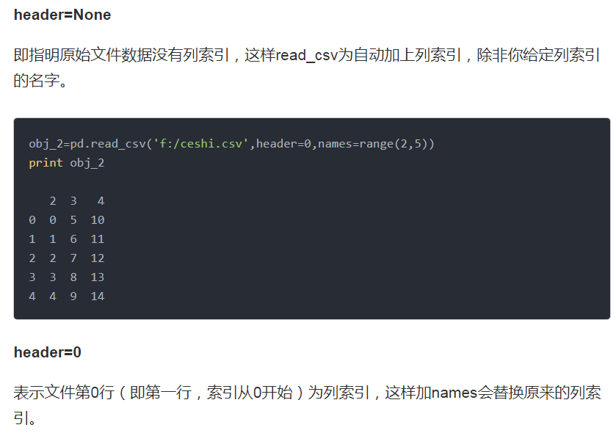
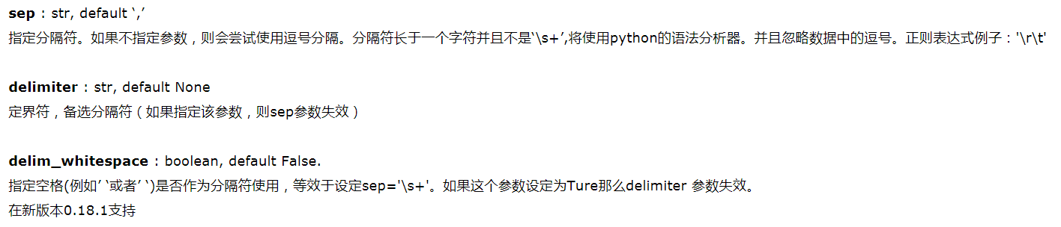
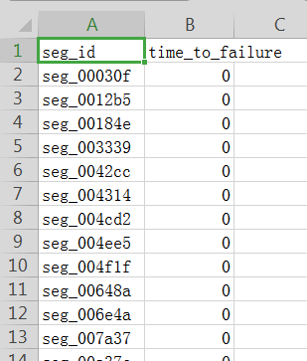
submission.index
submission.to_csv(submit_name)
seg = pd.read_csv(test_dir + seg_id + '.csv')
x = seg['acoustic_data'].values[:]

